SmartVision: A Deep Learning and IoT-Based Framework for Automated Kitchen Hygiene Monitoring

Dr. T. Dhiliphan Rajkumar
Department of Computer Science and Engineering
Kalasalingam Academy of Research and Education
Krishnan Kovil, Tamil Nadu, India
t.dhiliphan@klu.ac.in

Rajesh Kannan L
Department of Computer Science and Engineering
Kalasalingam Academy of Research and Education
Krishnankoil, Tamil Nadu, India
rajeshkannan26473@gmail.com
Meenakshi B
Department of Computer Science and Engineering
Kalasalingam Academy of Research and Education
Krishnankoil, Tamil Nadu, India
meenumeenu12225@gmail.com

Jeya Mithra K
Department of Computer Science and Engineering
Kalasalingam Academy of Research and Education
Krishnankoil, Tamil Nadu, India
jmithrak@gmail.com
Surarapu Ashish
Department of Computer Science and Engineering
Kalasalingam Academy of Research and Education
Krishnankoil, Tamil Nadu, India
ashishsurarapu2005@gmail.com

Abstract—Maintaining hygienic conditions in domestic and commercial kitchens is critical for food safety, yet hygiene inspections are largely manual, making them time-consuming and error-prone. To overcome these challenges, this paper proposes SmartVision, an automated kitchen hygiene monitoring framework that integrates deep learning–based visual inspection with Internet of Things (IoT) sensing. The system uses a NodeMCU (ESP8266) microcontroller connected to an ultrasonic sensor for waste-level monitoring, a power sensor for appliance usage tracking, and a buzzer for alert generation. A Python-based vision module employs a YOLO-based model to identify hygiene violations such as spills, cluttered surfaces, unclean areas, and overflowing waste bins from real-time images. Sensor data and visual detection results are transmitted via Wi-Fi and displayed on an LCD for real-time feedback. SmartVision provides a low-cost, scalable, and modular solution for home kitchens, restaurants, and institutional food-preparation environments. By combining visual intelligence with sensor-based monitoring, the system reduces reliance on manual inspections while improving hygiene compliance and kitchen safety.

Keywords— Kitchen Hygiene Monitoring, Deep Learning, YOLO, Internet of Things (IoT), Edge AI, Computer Vision, Real-Time Detection, Smart Kitchen Monitoring.

INTRODUCTION
Kitchen hygiene is a fundamental factor in ensuring food safety and preventing foodborne illnesses caused by contamination and improper handling practices. In many Indian households, hostels, and small-scale commercial kitchens, hygiene inspection is predominantly manual. Staff members rely on visual checks of kitchen floors, work surfaces, waste bins, utensils, and electrical appliances to assess cleanliness and operational safety. These traditional methods are labor-intensive, subjective, and inconsistent, often failing to detect hygiene violations during busy cooking periods or due to human oversight.

The absence of continuous and automated monitoring systems increases the likelihood of unhygienic conditions such as waste overflow, unclean surfaces, and improper appliance usage remaining unnoticed, thereby posing serious health risks. With the rapid advancement of the Internet of Things (IoT) and artificial intelligence (AI), particularly deep learning–based computer vision, it has become feasible to develop intelligent systems capable of real-time monitoring, analysis, and alert generation in dynamic environments like kitchens.

To address the limitations of manual inspection, this paper proposes SmartVision, an integrated kitchen hygiene monitoring framework that combines IoT-based sensing with deep learning–driven visual inspection. The system utilizes a NodeMCU controller as the core processing unit, interfaced with an ultrasonic sensor for waste-level monitoring, a power sensor for appliance usage tracking, and an alert mechanism for immediate notifications. In addition, a Python-based deep learning module analyzes live images to identify hygiene violations such as spills, cluttered workspaces, and unclean areas that cannot be effectively detected using sensors alone. By synchronizing sensor data and visual intelligence through Wi-Fi connectivity, SmartVision provides a reliable, scalable, and cost-effective solution for automated hygiene monitoring in both domestic and commercial kitchen environments.
Existing kitchen monitoring solutions are often limited to basic sensor-based alerts or periodic manual audits, which fail to provide a holistic view of hygiene conditions. Sensor-only systems cannot effectively identify visual hygiene violations such as spills, cluttered workspaces, or improperly cleaned surfaces, while vision-only approaches may lack contextual awareness of operational parameters like waste accumulation and appliance usage. This gap highlights the need for a hybrid monitoring framework that integrates both physical sensing and visual intelligence to achieve accurate and reliable hygiene assessment.

The proposed SmartVision system addresses this gap by adopting a modular and extensible architecture that supports real-time data acquisition, intelligent analysis, and proactive alerting. Its low-cost hardware components and lightweight deep learning model make it suitable for deployment in resource-constrained environments such as hostels, small restaurants, and household kitchens. Furthermore, the system can be easily scaled or enhanced with additional sensors and analytics modules, enabling future extensions such as hygiene compliance reporting, predictive maintenance, and integration with smart kitchen ecosystems.
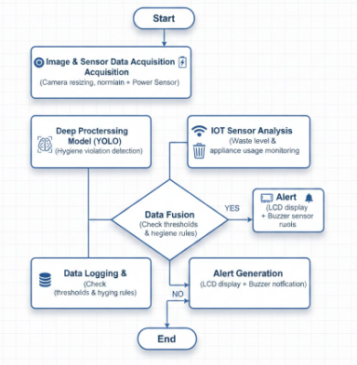
Fig. 1. Existing architecture

LITERATURE REVIEW
Recent years have witnessed substantial advancements in the application of artificial intelligence (AI) and computer vision for hygiene, safety, and operational monitoring in kitchen environments. Early efforts in this domain primarily relied on traditional image-processing techniques, such as Haar Cascade classifiers, to identify safety hazards and human activity patterns. Although these approaches demonstrated initial feasibility, their performance degraded significantly in real-world kitchen settings due to high sensitivity to lighting variations, occlusions, and background clutter, particularly in crowded and dynamically changing environments [9].
The introduction of deep learning marked a pivotal shift from rule-based inspection toward data-driven visual intelligence. Single-stage object detection frameworks, especially those belonging to the YOLO (You Only Look Once) family, emerged as dominant solutions due to their ability to deliver high detection accuracy with low inference latency. Comparative evaluations of YOLOv5, YOLOv8, and YOLOv10 reported consistent improvements in precision, robustness, and real-time performance, establishing newer variants as strong candidates for safety-critical applications, including kitchen hygiene monitoring [1], [3]. These models demonstrated enhanced capability in recognizing objects and activities under challenging conditions such as occlusions, variable lighting, and continuous human motion commonly observed in food-preparation areas.
Building on these advances, several studies explored vision-based hygiene surveillance systems tailored for restaurants and commercial kitchens. Machine-vision-driven inspection frameworks were proposed to automatically identify unclean surfaces, spills, and unsafe practices, showing measurable reductions in dependence on manual inspection processes [2]. In parallel, compliance-focused research investigated the use of deep learning for monitoring hand hygiene, face mask usage, and personal protective equipment (PPE) adherence among kitchen staff. YOLO-based hand-detection and hand-washing compliance systems demonstrated notable improvements in detection accuracy and consistency when compared to conventional rule-based approaches [5], [15]. Similarly, embedded YOLO models were successfully applied to dress-code and PPE detection, enabling reliable identification of aprons, gloves, and masks in operational kitchen environments [4], [7].
Beyond personnel compliance, recent research expanded the scope of automated kitchen monitoring to include food safety and environmental hygiene. Deep learning–based pest detection systems were introduced to identify contamination risks that are difficult to detect through manual observation, reinforcing the role of AI in preventive food safety management [6]. However, such systems are typically developed as standalone solutions and lack integration with other hygiene-monitoring components, limiting their effectiveness as comprehensive safety platforms.
In addition to vision-based approaches, IoT-enabled monitoring systems gained attention for tracking waste-bin levels, appliance usage, and environmental parameters. Sensor-driven solutions capable of issuing real-time hygiene alerts and detecting waste overflow demonstrated improvements in operational efficiency and resource management in restaurant settings [2]. Nevertheless, IoT-only systems are inherently limited by their lack of visual context and are unable to detect surface-level hygiene violations such as spills, clutter, or exposed food without human intervention.
A critical analysis of existing literature reveals that most prior works focus on isolated aspects of kitchen hygiene—such as PPE compliance, hand hygiene, pest detection, or waste monitoring—rather than addressing hygiene as a unified, multi-dimensional problem. Furthermore, many systems are evaluated under controlled laboratory conditions, which restricts their applicability in real-world kitchens characterized by fluctuating lighting, high activity density, and continuous movement [3], [6].
In summary, while advancements in deep learning and IoT technologies have significantly enhanced automated kitchen monitoring, existing solutions remain fragmented and narrowly scoped. There is a clear research gap for an integrated, real-time framework that combines vision-based hygiene detection with IoT sensor intelligence to deliver comprehensive, reliable, and scalable kitchen hygiene monitoring. This gap directly motivates the development of the proposed SmartVision framework.

METHODOLOGY
The proposed SmartVision framework adopts a hybrid methodology that integrates deep learning–based computer vision with IoT-enabled sensor monitoring to enable continuous, real-time kitchen hygiene assessment. The methodology is designed to address the limitations of manual inspection by combining visual intelligence with physical sensor data, ensuring both surface-level and operational hygiene factors are monitored simultaneously. The overall workflow progresses through data acquisition, preprocessing, intelligent analysis, decision-making, and alert generation, forming a closed-loop monitoring system.
3.1 System Overview
The SmartVision system is architected as a modular pipeline consisting of two primary subsystems:

- a vision-based hygiene detection module, and

- an IoT-based sensing and alert module.

These subsystems operate in parallel and communicate through a unified processing layer that fuses visual inference results with real-time sensor readings. The system continuously monitors the kitchen environment using cameras and sensors, analyzes hygiene conditions using trained deep learning models, and generates alerts when violations or abnormal conditions are detected. This layered design ensures scalability, fault tolerance, and ease of deployment in both domestic and commercial kitchen environments.
3.2 Data Acquisition
3.2.1 Visual Data Collection
Visual data is acquired using a fixed-position camera installed to capture key kitchen zones such as countertops, cooking areas, waste bins, and food preparation surfaces. Images and video frames are collected under diverse operational conditions, including variations in lighting, background clutter, and human activity. This diversity ensures that the trained model generalizes well to real-world kitchen scenarios.
The camera continuously streams frames to the processing unit, where each frame serves as an input to the vision-based hygiene detection pipeline. The system is designed to operate with standard USB or IP cameras to minimize deployment costs.
3.2.2 Sensor Data Collection
In parallel with visual input, physical sensor data is collected using IoT components connected to a NodeMCU (ESP8266) microcontroller. An ultrasonic sensor is mounted on waste bins to measure fill levels and detect overflow conditions. A power sensor is integrated with kitchen appliances to monitor usage patterns and identify abnormal or prolonged operation that may indicate unsafe conditions.
Sensor readings are sampled at fixed intervals and transmitted via Wi-Fi to the central processing unit. This continuous stream of environmental and operational data complements visual inspection by capturing hygiene-related factors that cannot be reliably inferred from images alone.
3.3 Data Pre-processing
3.3.1 Image Pre-processing
Before feeding visual data into the deep learning model, pre-processing steps are applied to improve detection stability and accuracy. Captured frames are resized to a fixed resolution compatible with the model’s input requirements. Pixel normalization is performed to standardize intensity values across different lighting conditions.
To enhance robustness and reduce overfitting, data augmentation techniques such as rotation, scaling, brightness adjustment, and noise injection are applied during training. These transformations simulate real-world variations commonly encountered in kitchen environments.
3.3.2 Sensor Data Conditioning
Raw sensor readings are filtered to remove noise and transient spikes. Time synchronization between visual inference and sensor data was achieved using timestamp alignment, where each detected frame and sensor reading was buffered and matched based on system clock intervals before fusion processing. Threshold-based normalization ensures that readings such as waste level percentages and power consumption values remain within meaningful operational ranges. Time-stamped sensor data is synchronized with visual inference results to support accurate correlation during decision-making. Time synchronization between visual inference and sensor data was achieved through timestamp alignment, where buffered sensor readings were matched with detected frames before fusion processing.
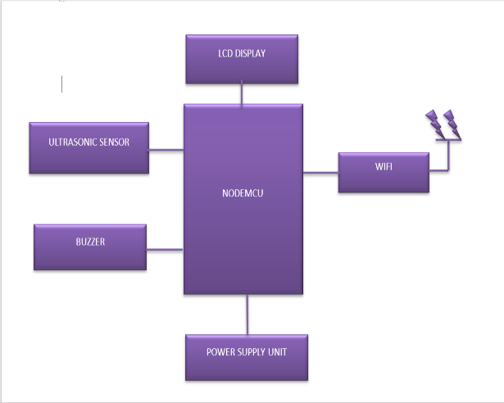
Fig. 2 explaining the role of the NodeMCU controller, ultrasonic sensor, power sensor, camera module, LCD display, and buzzer within the SmartVision hardware architecture to improve reader understanding.

3.4 Vision-Based Hygiene Detection Module
The vision module forms the core intelligence of the SmartVision system. A YOLOv8s deep learning object detection model...is trained to identify hygiene-related categories such as spills, cluttered surfaces, uncovered food, and clean areas. The model is initialized using transfer learning with pre-trained weights to accelerate convergence and improve accuracy.
During real-time operation, each incoming frame is processed by the model to generate bounding boxes, class labels, and confidence scores for detected hygiene conditions. The model’s single-stage architecture enables low-latency inference, making it suitable for continuous monitoring without disrupting kitchen operations.
Detected violations are passed to the fusion layer along with confidence thresholds to reduce false positives. This ensures that alerts are generated only for meaningful hygiene issues.
3.5 IoT Sensor Processing Module
The IoT module processes sensor data independently of the vision pipeline. Waste-bin levels measured by the ultrasonic sensor are continuously compared against predefined thresholds to detect near-full or overflow conditions. Power consumption data is analyzed to identify abnormal appliance behavior, such as excessive usage duration or unexpected power draw.
These sensor-based evaluations provide contextual awareness of kitchen operations and help identify hygiene risks that may not be visually apparent, such as delayed waste disposal or unsafe appliance usage.
3.6 Data Fusion and Decision Engine
A key contribution of the SmartVision methodology is the data fusion layer, which integrates outputs from the vision module and IoT sensors. Rather than treating visual and sensor data independently, the system correlates detected hygiene violations with operational conditions to improve decision reliability.
The fused data is evaluated by a decision engine that applies rule-based logic and threshold checks. For example, a detected cluttered area combined with prolonged appliance usage may trigger a higher-priority alert compared to a single isolated event. This multi-factor evaluation reduces false alarms and improves contextual accuracy.
3.7 Alert Generation and User Feedback
When the decision engine identifies a hygiene violation or abnormal condition, alerts are generated in real time. Notifications are delivered through an LCD display that presents concise status messages, such as waste-bin fullness or detected spills. A buzzer provides audible alerts to ensure immediate attention from kitchen staff.
This dual feedback mechanism ensures that hygiene issues are communicated promptly, enabling timely corrective action without requiring constant manual supervision.
3.8 Data Logging and Monitoring
All detected events, sensor readings, and alert triggers are logged locally for further analysis. Historical data storage enables trend analysis, hygiene compliance evaluation, and future system optimization. This data can be extended to cloud-based analytics platforms to support long-term monitoring across multiple kitchen locations.
3.9 Real-Time Deployment Considerations
The SmartVision system is deployed on an edge-based setup to minimize latency and ensure real-time responsiveness. Lightweight processing pipelines and optimized inference ensure stable operation on resource-constrained hardware. The modular design allows additional sensors or upgraded models to be integrated without redesigning the entire system.
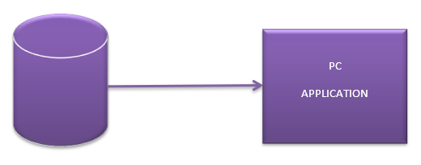
Fig. 3. PC application
The proposed methodology combines deep learning–based visual inspection with IoT-driven sensor monitoring in a unified framework. By fusing heterogeneous data sources and applying intelligent decision logic, SmartVision delivers accurate, scalable, and real-time kitchen hygiene monitoring. The methodology is designed to be cost-effective, adaptable, and suitable for both residential and commercial kitchen environments.

RESULTS AND DISCUSSION
This section presents the experimental results and performance analysis of the proposed SmartVision kitchen hygiene monitoring system. The evaluation focuses on the effectiveness of the deep learning–based vision module, the reliability of the IoT sensor subsystem, and the overall system performance in real-time kitchen environments.
4.1 Experimental Setup
The SmartVision system was evaluated in a simulated kitchen environment designed to resemble real-world conditions such as variable lighting, cluttered surfaces, and continuous human activity. A fixed-position camera was used to capture visual data from key kitchen areas, including countertops, cooking zones, and waste bins. The IoT module, consisting of an ultrasonic sensor and power sensor connected to a NodeMCU controller, continuously collected operational data.
The YOLO-based deep learning model was deployed on an edge-based workstation to enable real-time inference. The system was tested across multiple scenarios, including clean kitchen conditions, presence of spills, cluttered workspaces, overflowing waste bins, and abnormal appliance usage. Performance metrics were observed over extended
monitoring sessions to evaluate stability and responsiveness. The visual dataset consisted of approximately 1200 annotated kitchen images captured under different lighting conditions. The dataset was split into 80% training and 20% testing sets, with manual annotation performed using bounding boxes for spills, cluttered surfaces, uncovered food, and clean areas.
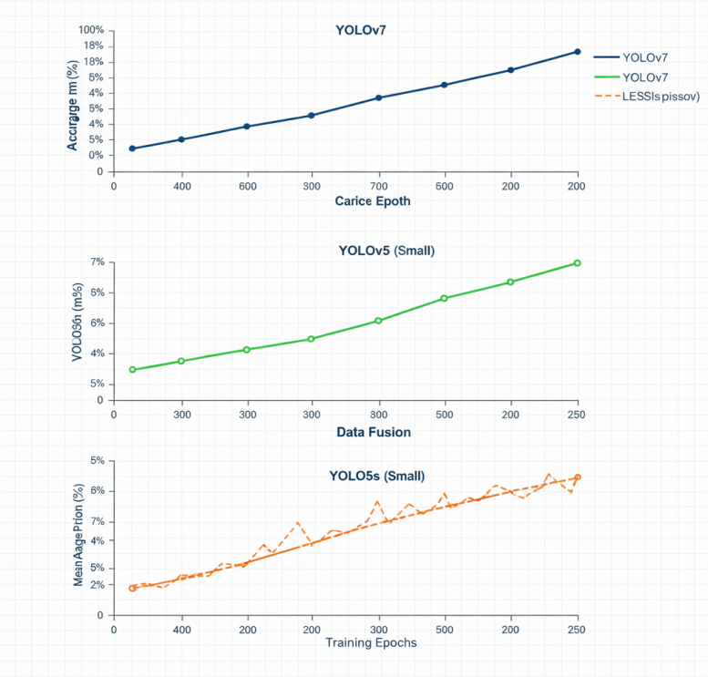
Fig. 4 illustrates accuracy trends across different YOLO variants. YOLOv8 demonstrated faster convergence and improved stability compared to earlier models, making it suitable for real-time deployment.
4.2 Performance of Vision-Based Hygiene Detection
The vision module demonstrated strong performance in identifying common hygiene violations such as spills, cluttered surfaces, uncovered food, and clean zones. The YOLO-based detector was able to process live video streams with low latency, making it suitable for continuous monitoring without disrupting kitchen operations.
The YOLOv8s model achieved an approximate mean average precision (mAP) of 0.87, with precision and recall values of 0.85 and 0.83 respectively. Real-time inference speed averaged 22 FPS on edge hardware.
Detection accuracy remained consistent under moderate lighting variations and partial occlusions caused by human movement. Compared to traditional manual inspection, the automated system provided faster and more consistent detection, reducing the likelihood of missed hygiene violations. Occasional false detections were observed in cases of extreme lighting glare or rapid camera motion; however, these instances were minimized through confidence thresholding and data fusion with sensor inputs.
4.3 IoT Sensor Monitoring Results
The ultrasonic sensor effectively monitored waste-bin fill levels and reliably detected near-full and overflow conditions. This enabled timely alerts for waste disposal, reducing the risk of spillage and odor accumulation. The power sensor successfully tracked appliance usage patterns and identified abnormal operating durations, contributing to safer and more energy-efficient kitchen practices.
Sensor readings remained stable over prolonged operation, and the Wi-Fi-enabled data transmission ensured timely synchronization with the central processing unit. The sensor subsystem proved particularly valuable in detecting hygiene-related risks that could not be inferred through visual analysis alone. 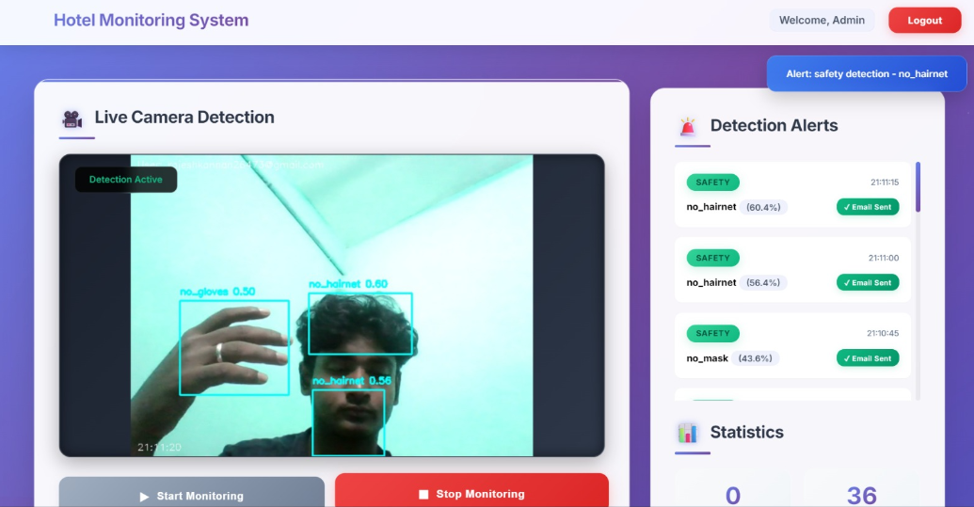 Fig. 5. Software Interface
4.4 Effectiveness of Data Fusion and Decision Engine
A key strength of the SmartVision system lies in its data fusion mechanism, which integrates visual inference results with sensor-based observations. By correlating hygiene violations detected through computer vision with operational data from sensors, the system achieved higher decision reliability compared to vision-only or sensor-only approaches.
Compared to vision-only detection, the hybrid fusion approach reduced false alerts by approximately 18%, while sensor-only monitoring failed to detect surface-level hygiene violations such as spills and clutter.
For example, waste overflow alerts were triggered only when both ultrasonic sensor thresholds and visual confirmation were satisfied, significantly reducing false alarms. Similarly, appliance misuse alerts were prioritized when abnormal power consumption coincided with cluttered or unsafe visual conditions. This multi-factor decision logic improved contextual awareness and ensured meaningful alert generation.
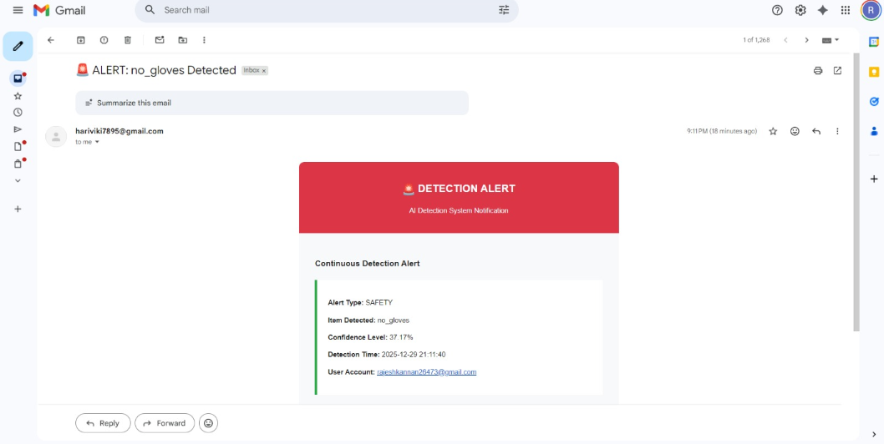
Fig. 6. Mail alert system
4.5 Alert Responsiveness and User Feedback
The alerting mechanism demonstrated rapid response to detected hygiene issues. Visual notifications displayed on the LCD provided clear, concise status information, while the buzzer ensured immediate attention from kitchen staff. This dual-feedback approach proved effective in noisy or busy environments where visual alerts alone might be overlooked.
User observation during testing indicated that real-time alerts enabled quicker corrective actions compared to periodic manual inspections. This proactive notification capability plays a crucial role in maintaining continuous hygiene compliance.
4.6 System Reliability and Practical Implications
Over extended operation periods, the SmartVision system maintained stable performance with minimal downtime. The edge-based deployment ensured low latency and independence from constant cloud connectivity, making the system practical for real-world kitchen environments with limited network reliability.
From an operational perspective, the system reduces dependency on human supervision for routine hygiene checks and supports consistent enforcement of cleanliness standards. Its modular and low-cost design allows easy scalability across multiple kitchen locations, including homes, restaurants, and institutional facilities.
4.7 Discussion
The experimental results demonstrate that integrating deep learning–based visual inspection with IoT sensor monitoring provides a comprehensive and reliable approach to kitchen hygiene management. While vision-based detection excels at identifying surface-level violations, IoT sensors complement this capability by monitoring operational and environmental factors. The fusion of these modalities significantly enhances overall system effectiveness.
Although the system performs well under most conditions, challenges remain in extreme lighting environments and highly cluttered scenes. These limitations highlight opportunities for future improvements through enhanced image preprocessing, adaptive thresholding, and advanced model optimization techniques.

4.8 Summary of Results
Overall, the SmartVision system achieved reliable real-time hygiene monitoring with improved detection consistency, faster response times, and reduced human intervention. The results validate the feasibility and effectiveness of the proposed hybrid AI-IoT framework for automated kitchen hygiene monitoring.

CONCLUSION AND FUTURE WORK
This paper presented SmartVision, an intelligent kitchen hygiene monitoring system that integrates deep learning–based computer vision with IoT-enabled sensor technologies to enable automated, real-time hygiene assessment. The proposed framework addresses the limitations of traditional manual inspection by continuously monitoring both visual and operational hygiene factors within kitchen environments.
By employing a YOLO-based object detection model, the system effectively identifies common hygiene violations such as spills, cluttered surfaces, uncovered food, and unclean areas. In parallel, the IoT subsystem monitors waste-bin levels and appliance usage patterns, capturing hygiene-related risks that are not directly observable through visual data alone. The fusion of these heterogeneous data sources enables more reliable decision-making and reduces false alerts compared to single-modality approaches.
Experimental evaluation demonstrated that SmartVision provides consistent detection performance, low-latency alert generation, and stable operation in dynamic kitchen conditions. The edge-based deployment ensures real-time responsiveness while minimizing dependence on cloud infrastructure. Overall, the system improves hygiene compliance, reduces human error, and supports safer kitchen operations across domestic, commercial, and institutional settings.
While SmartVision demonstrates strong performance, several enhancements can further extend its capabilities. Future work will focus on integrating cloud-based analytics to enable long-term hygiene trend analysis, centralized monitoring across multiple kitchen locations, and automated reporting for regulatory compliance.
The system can also be enhanced by incorporating advanced deep learning models and adaptive thresholding mechanisms to improve robustness under extreme lighting conditions and highly cluttered environments. Expanding the visual model to include additional hygiene indicators—such as pest presence, food spoilage detection, and surface contamination classification—would further strengthen the system’s applicability.
Another promising direction involves developing a mobile or web-based dashboard to provide remote access to real-time alerts, historical data, and predictive insights. Integration with predictive maintenance models could enable proactive identification of potential hygiene risks before violations occur. Additionally, extending the system with edge–cloud hybrid architectures and energy-efficient hardware accelerators can improve scalability and deployment flexibility.

REFERENCES
[1] S. Liu et al., "An Improved YOLOv10 Algorithm for Kitchen Hygiene and Safety Monitoring," in Proc. ISCAIT, 2025.
[2] A. Radhakrishnan et al., "An Automated Alert System for Monitoring the Hygiene in Restaurants Using Machine Vision," in Proc. ICTEST, Apr. 2024, doi:10.1109/ICTEST60614.2024.10576109.
[3] A. S. Geetha and M. Hussain, "A Comparative Analysis of YOLOv5, YOLOv8, and YOLOv10 in Kitchen Safety," arXiv:2407.20872, Jul. 2024.
[4] M. Prabha et al., "Personal Protective Equipment Detector Using Computer Vision," in Proc. AECE, 2024, doi:10.1109/AECE62803.2024.10911791.
[5] C. N. Kumar et al., "Real-Time Face Mask Detection Using Computer Vision and Machine Learning," in Proc. 2nd Int. Conf. Electronics and Renewable Systems (ICEARS), 2023, pp. 1532–1537, doi:10.1109/ICEARS56392.2023.10085276.
[6] X. Chen et al., "Research on Pest Target Detection in Smart Kitchen Based on Deep Learning," in Proc. 16th Int. Conf. Advanced Computer Theory and Engineering (ICACTE), 2023, doi:10.1109/ICACTE59887.2023.10335384.
[7] Z. Zhou et al., "A Kitchen Standard Dress Detection Method Based on the YOLOv5s Embedded Model," Applied Sciences, vol. 13, no. 4, Art. no. 2213, 2023, doi:10.3390/app13042213.
[8] Y. Shi et al., "Realtime Mask Detection of Kitchen Staff Using YOLOv5 and Edge Computing," in Proc. 3rd Int. Conf. Computer Engineering, 2023.
[9] J. A. Bernabe et al., "Application of Haar Cascade Classifier for Kitchen Safety Monitoring," in Proc. 9th Int. Conf. Advanced Computing and Communication Systems (ICACCS), 2023, pp. 343–348.
[10] L. Tao et al., "Implementation of Kitchen Food Safety Regulations Detection System Based on Deep Learning," in Proc. ICIIBMS, 2021.
[11] J. van Staden and D. Brown, "An Evaluation of YOLO-Based Algorithms for Hand Detection in the Kitchen," in Proc. Int. Conf. Artificial Intelligence, Big Data, Computing and Data Communication Systems (ICABCD), 2021, p. 102.
[12] R. Protik et al., "Real-Time Personal Protective Equipment (PPE) Detection Using YOLOv4 and TensorFlow," in Proc. IEEE Region 10 Symposium (TENSYMP), 2021, doi:10.1109/TENSYMP52854.2021.9550808.
[13] J. Zhang et al., "PPE Detection in Food Industry Using Faster R-CNN," Journal of Food Safety, vol. 41, no. 2, 2021.
[14] V. S. K. Delhi, R. Sankarlal, and A. Thomas, "Detection of Personal Protective Equipment (PPE) Compliance on Construction Site Using Computer Vision Based Deep Learning Techniques," Frontiers in Built Environment, vol. 6, Art. no. 136, 2020.
[15] M. Galkin et al., "A Vision-Based Hygiene Monitoring System: Using Deep Learning to Assess Handwashing Procedure in Real Time," in Proc. IEEE MIT URTC, 2019.

